BIOINFORMATIC TASK - CODEALPHA
DNA Sequence and BLAST Analysis of the blaNDM-1 Gene
Introduction
Antimicrobial resistance is a global health concern, especially resistance to carbapenem antibiotics, which are used to treat infections caused by multidrug resistant Gram-negative bacteria. The blaNDM-1 gene encodes New Delhi metallo-β-lactamase-1 (NDM-1), an enzyme that causes resistance to carbapenem and other β-lactam antibiotics.
Using Bioinformatics tools, DNA sequences and identifying homologous sequences in publicly available databases. The Basic Local Alignment Search Tool (BLAST) is used to identify regions of similarity between a query sequence and sequences found in biological databases.
In this project, a blaNDM-1 DNA sequence from Klebsiella pneumoniae was retrieved from the National Center for Biotechnology Information (NCBI) database and analyzed using BLASTn to find homologous nucleotide sequences.
Objective
- Retrieve a DNA sequence which has the blaNDM-1 gene from NCBI.
- Perform nucleotide BLAST to find homologous sequences.
- Determine the percentage identity and query coverage of the sequences.
- Evaluate the statistical significance of the sequence matches using E-values.
- Compare the alignment scores of the identified homologous sequences.
Materials and Methods
Sequence retrieval
A nucleotide sequence containing the blaNDM-1 gene was obtained from the NCBI Nucleotide database. The sequence was obtained in FASTA format and used as the query sequence for BLAST analysis.
BLAST analysis
The sequence was analyzed using NCBI BLASTn against the core_nt nucleotide database. The BLAST search was performed using the Highly similar sequences (megablast) option. The homologous sequences were evaluated based on: Query coverage, percentage identity, E-value, maximum alignment score, accession number and organism and sequence description
Results
Figure 1: The NCBI nucleotide results Klebsiella pneumoniae strain Res2010-21 blaNDM-1 gene
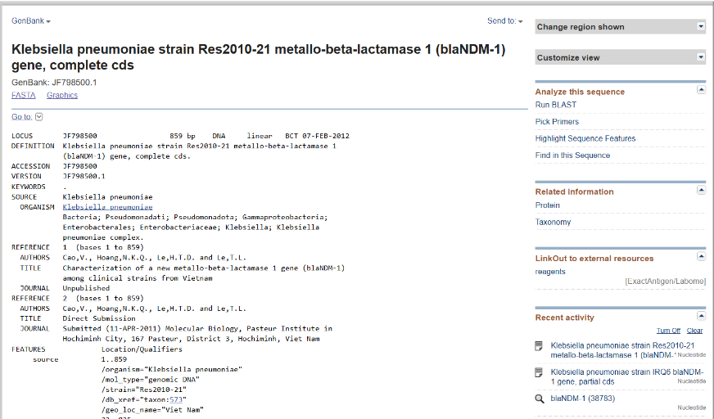
Figure 2: BLASTn results for the blaNDM-1 query sequence
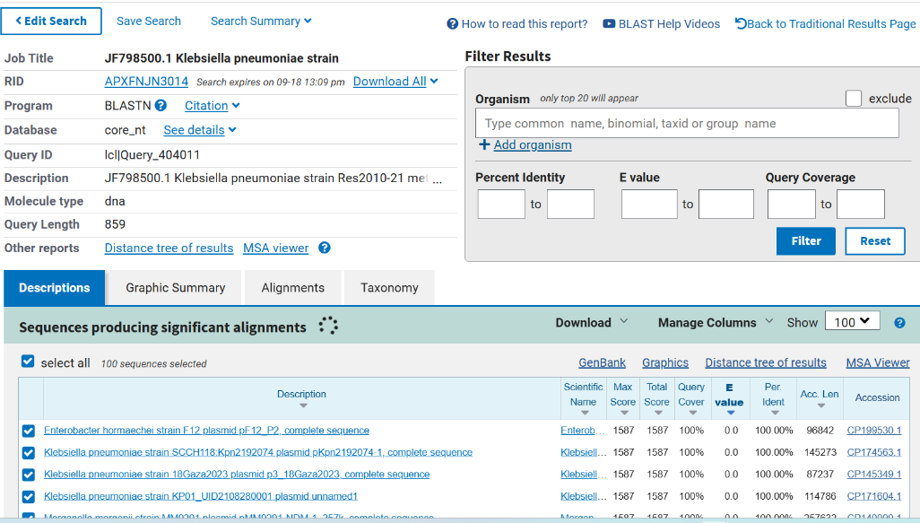
The first five sequences showed 100% query coverage and 100% nucleotide identity, with an E-value of 0.0.
Figure 3: Alignment Analysis, The individual alignment between the query and a selected BLAST hit.
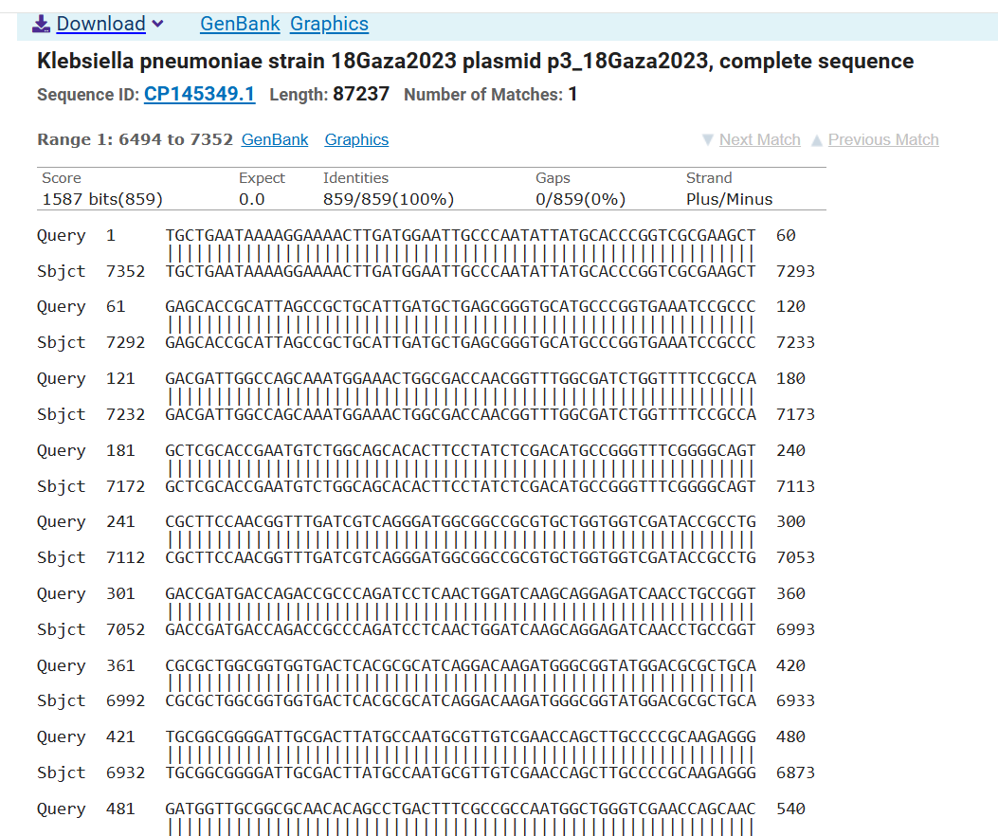

Discussion
Several of the matching sequences were associated with plasmids. This result is important to antimicrobial resistance because resistance genes can occur on mobile genetic elements, allowing resistance determinants to be found in different bacterial backgrounds.
Therefore, the results show how BLAST is used to identify homologous sequences and examine the distribution and conservation of an antimicrobial resistance associated gene across available sequence records.
Sequence similarity alone does not show how a resistance gene was passed between organisms. Further analyses, such as plasmid comparison, genomic context analysis, phylogenetic analysis and molecular epidemiology, are required to investigate the evolutionary and transmission relationships between these sequences.
Conclusion
The blaNDM-1 DNA sequence from Klebsiella pneumoniae was successfully retrieved from the NCBI database and analyzed using BLASTn. Multiple highly similar sequences were identified in the nucleotide database.
A 100% query coverage, 100% nucleotide identity and an E-value of 0.0, shows significant sequence matches. The homologous sequences were found in different bacterial species and included sequences associated with plasmids.

References
- NCBI. National Center for Biotechnology Information. National Library of Medicine. Nucleotide database and BLAST.
- Altschul SF, Gish W, Miller W, Myers EW, Lipman DJ. Basic local alignment search tool. Journal of Molecular Biology. 1990;215(3):403–410.

